WEEK 4
Aim:To determine whether the two halves of a given string contain an equal number of vowels.

Algorithm:
- Read the input string s.
- Divide the string into two halves:
  - First half → index 0 to length/2 - 1
  - Second half → index length/2 to length - 1
- Initialize two counters count1 and count2.
- Traverse the first half:
  - If a character is a vowel (a, e, i, o, u in both cases), increment count1.
- Traverse the second half:
  - If a character is a vowel, increment count2.
- Compare both counts:
  - If equal → return true
  - Else → return false
Program:
class Solution {
public boolean halvesAreAlike(String s) {
int n = s.length();
int count1 = 0, count2 = 0;
String vowels = "aeiouAEIOU";
for (int i = 0; i < n / 2; i++) {
if (vowels.indexOf(s.charAt(i)) != -1) {
count1++;
}
}
for (int i = n / 2; i < n; i++) {
if (vowels.indexOf(s.charAt(i)) != -1) {
count2++;
}
}
return count1 == count2;
}
}
Output:
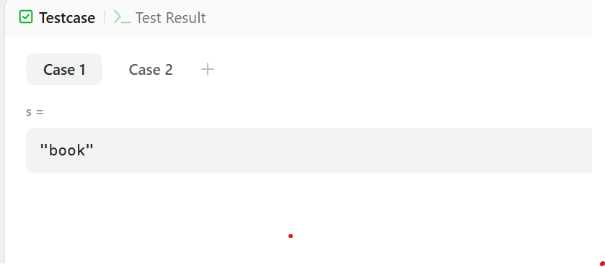

Result
The program successfully checks whether both halves of the string contain an equal number of vowels and returns true or false accordingly was executed successfully and output was verified.

Aim:
To check whether a given string is a Lapindrome, meaning both halves of the string have the same character frequency.

Algorithm:
- Read the input string s.
- Find the length of the string.
- Divide the string into two halves:
  - If length is even → split equally.
  - If length is odd → ignore the middle character.
- Create two frequency arrays of size 26 for alphabets.
- Traverse the first half and store character frequencies.
- Traverse the second half and store character frequencies.
- Compare both frequency arrays:
  - If equal → print "YES"
  - Else → print "NO"
Program:
import java.util.*;
public class Main {
public static void main(String[] args) {
Scanner sc = new Scanner(System.in);
int t = sc.nextInt();
while (t-- > 0) {
String s = sc.next();
int n = s.length();
int[] freq = new int[26];
for (int i = 0; i < n / 2; i++) {
freq[s.charAt(i) - 'a']++;
}
for (int i = (n + 1) / 2; i < n; i++) {
freq[s.charAt(i) - 'a']--;
}
boolean isLapindrome = true;
for (int count : freq) {
if (count != 0) {
isLapindrome = false;
break;
}
}
System.out.println(isLapindrome ? "YES" : "NO");
}
sc.close();
}
}
Output:
gaga
abcde
rotor
YES
NO
YES

Result
The program correctly identifies whether the given string is a Lapindrome and prints YES or NO was executed successfully and output was verified.

